THE VERBAL-KINESIC ENACTMENT OF CONTRAST IN NORTH AMERICAN ENGLISH

Jennifer Hinnell | University of Alberta
hinnell@ualberta.ca | www.JenniferHinnell.com

Abstract
In this paper, I explore the linguistic and kinesic expression of contrast – the pitting of one position, object, or idea, against another. The archetype utterance for the embodied expression of contrast in English is the bipartite construction On the one hand… On the other hand…, in which hand gestures are often performed sequentially along the sagittal axis (first on one side and then on the other side of the body) to depict the two options. However, English speakers have a variety of other linguistic means available to them for expressing contrast. Using data from naturally occurring discourse, I describe a range of linguistic resources that mark contrast and examine the semiotic relationships at play in the dynamic, multimodal signs (i.e. speech/gesture constructions) that accompany them. I demonstrate that, far from being ad hoc, when analyzed across the propositional, cognitive, and discursive domains, the way in which contrast is marked in the body can be viewed on a continuum of highly imageable to more schematically iconic kinesic movements. By placing the primary focus on the multimodal sign, this paper makes clear how speakers of North American English build semiotic environments around the construal of contrast.

Keywords: contrast, opposition, multimodality, iconicity, indexicality, co-speech gesture

Introduction
Imagine a friend invites you to do something daring, like ride a motorcycle. You might say Yes! without reservation. If you are somewhat risk-averse, though, you might voice your indecision by saying On the one hand I’d love to, and let your voice trail off, or you may offer an assessment such as That looks like fun, but it might be dangerous. Weighing options and making choices are part of the experience of being human. In fact, various sources estimate that an adult makes about 35,000 decisions every day and children about 3,000 (Sahakian & Labuzetta 2013). These staggering numbers aside, the variety of linguistic expressions at our disposal to communicate the options we face are also numerous. English has many expressions that are built to express two alternatives. The archetype is the semi-fixed expression On the one hand…. On the other hand…. The simple binary operator or, comparative adjectives like better and worse, demonstratives such as this and that, and adverbials such as here and there, also inherently contrast two options. Even pronouns have opposites, as in me rather than you, and us vs. them. With this wide range of devices in English, we mark contrast across a variety of domains, for instance, contrasting objects in the propositional domain (Are you having the chicken or the fish?), considering choices in the cognitive domain (Should I do it? Should I not do it?), and distancing ourselves from a previous discourse thread (however and anyways).
This wide array of verbal expressions of contrast in English is matched by a range of body movements. For example, as you formulate a response to your friend’s invitation to join her on the motorcycle ride mentioned above, you might move one hand to the side with your palm facing upwards as you say On the one hand I’d love to, or you might tilt your head first to one side and then the other as you say it might be fun but you’re worried it’s also dangerous. As I demonstrate in this paper, speakers use a variety of hand, head, and shoulder movements, as well as eye brow raising and gaze shifts, to mark contrast. The result is a robust marking of contrast in the body. Some enactments are signaled very strongly, such as the highly iconic and imageable bimanual gesture frequently associated with the idiomatic expression On the one hand…On the other hand…. Others enactments of contrast, though, are more reduced and schematic, such as subtle head tilts from side-to-side, or a gaze shift.
In this paper, I document a range of bodily behaviors that speakers enact when they express contrast in a variety of domains. Leaning on corpus linguistic methods and a cognitive linguistic framework, I use data from the Red Hen multimodal archive (Steen and Turner 2013) to investigate these enactments in relation to the linguistic cues with which they are aligned. I argue that while the level of abstraction differs between the recognizable iconicity of some enactments and the more schematic representations of others, the primary semiotic processes at play unify these speech-aligned behaviours as enacting the underlying cognitive construct of contrast. Furthermore, the data suggest that some of the variation in the enactments of contrast is motivated by the domain in which the utterance inheres. Thus, in a contrastive scenario, propositional, real world content is most likely to be indicated with manual gesture and is more highly imageable, while in the cognitive domain (e.g. Should I…? Shouldn’t I…?) it is more likely to be expressed through head movement. contrast in the discursive domain, in turn, has yet another profile and is more schematically referential.
A discussion of contrast can be seen in the context of the long history in semiotics of the role of opposition and difference in meaning making (e.g. de Saussure’s (1916) différence), reviewed briefly below. For the scope of the research presented here, I take contrast in a pre-theoretic sense to be an evaluation of options (thus not limited to binary opposition; see Nöth 1994 for an overview of opposition). The study is grounded in an embodied cognitive framework, whose central tenets include the crucial role of the body and the physical environment in structuring cognitive activities, including language (Bergen 2012; Johnson 2017; see also Pelkey 2017 on the bodily origins of chiasmus). As Johnson suggests, the aim of this ‘second-generation’ of cognitive science is:
to determine how – precisely and in detail - our bodies give rise to the meaning we can experience, the reasoning we do, and the ways we communicate with others, not just through language proper, but also through all our many forms of symbolic action in the arts and associated practices.
(Johnson 2017: 17)
This paper aims to answer Johnson’s implicit call, in small part, by analyzing the co-semiotics of speech and body utterances in the marking of contrast.
Within cognitively oriented research, there is a literature emerging that focuses on gesture, head movement, gaze, and other co-speech behaviours that accompany face-to-face interactions (Müller et al. 2013; Müller et al. 2014; Schoonjans 2014; Debras 2017; Hartmann et al. 2017; Jehoul et al. 2017). Previous studies using corpus linguistic methods have pursued the marking of stance – an umbrella term encompassing a speaker’s viewpoint, attitudes, or judgment (Biber and Finegan 1989; Precht 2000), of which assessments of contrast are an important sub-category. However, there are few corpus-based studies of spontaneous interaction related to specific conceptual domains from both a cognitive and a multimodal perspective (cf. Hinnell 2018 on aspect-marking in co-speech gesture), and there has yet to be an investigation of how different conventions in embodied form contribute to meaning in the marking of contrast. By examining the body concurrently with speech, this paper contributes to current work in embodied communication that sees the emergence of meaning in interaction as a co-production between multiple modalities (Feyaerts et al. 2017). It aims to shed new light on the ways of “human signification”, a central tenet of the transdisciplinary field of cognitive semiotics (Zlatev 2015: 1043). Furthermore, though opposition theory per se has not been a major focus in semiotics since the advent of post-structuralism (Danesi 2009), the interconnections that will be presented between linguistic and conceptual structures that encode difference and opposition should contribute to discussions regarding the applications of these theories (Assaf et al. 2015).

Contrast: Expressions and domains
Logically speaking, contrast is the pitting of one position vis-à-vis another. In English there are myriad ways of expressing a contrastive relationship. At the word level, antonyms express contrast, as in the case of antonymic polar adjectives (good/bad) and contrastive nominals (defense/offense). Quasi-grammatical conjunctive expressions such as versus in Clinton vs. Trump serve a similar function, as does the related fixed expression vice versa. A range of semi-fixed idiomatic expressions also provide speakers with mechanisms for evaluating options, as in the archetypal On the one hand… On the other hand, as well as related expressions such as On one side….
As mentioned above, just as the conceptual realm of contrast can be instantiated linguistically through an array of expressions, it can hold in a variety of domains. The range of expressions listed thus far are typically used by speakers to express options in the real, actual, described world (denoted by the semantic notion of realis) . However, the conceptual notion of contrast can equally apply in the irrealis, or hypothetical, world. For example, the contrasting of two mental states, as in Should I or shouldn’t I? has been described as alternativity (Dancygier & Sweetser 2005: 35). According to Dancygier and Sweetser, alternativity refers to two alternate spaces that are construed from the same base or reference space, but that are necessarily incompatible. Other space-building expressions in irrealis mood include pairs of conditional if-statements, such as the pair of utterances in (1).
- If Gary Johnson gets to that level, he’ll be on the stage. If he doesn’t get to that level, he won’t.
Finally, contrast can be instantiated in the domain of discourse. The group of devices known as concessives carve up the discourse space and mark a contrastive relation between clauses or sequences of clauses in a discourse. They are frequently described as a homogenous group and consist of functional items such as anyway, at any rate, but, conversely, however, nevertheless, on the contrary, though, and yet, among many others (Biber et al. 1999: 878). In the case of concession, rather than dealing with two mutually incompatible alternative spaces, the concessive signals a juncture along a path and a subsequent shift in direction. A speaker may depart from the “frame utterance” (Bolinger 1989: 185) to make a parenthetical comment (asides frequently introduced by fixed expressions such as which, by the way… and but I have to say…). The speaker then marks the return to the frame utterance, or in some cases the shift to a new topic, with a concessive device such as so anyways, but anyways, or at any rate. This articulation of a choice of direction along the discourse path is enacted with an increased degree of schematicity in the accompanying co-speech behavior that nonetheless inheres to some of the patterns in contrast marking seen in the other two domains treated here.
The most prototypical of the expressions noted above is the idiomatic expression On the one hand…On the other hand (henceforth, O1H-OOH), which, through direct reference to the hands, inherently invites the use of gesture to impart the pragmatic force of the expression. The setup is conventionally indicated with a palm-up-open-hand gesture (PUOH, Müller 2004) towards one side and the resolution through a subsequent PUOH gesture to the opposite side, as shown in the line drawing in Figure 1.
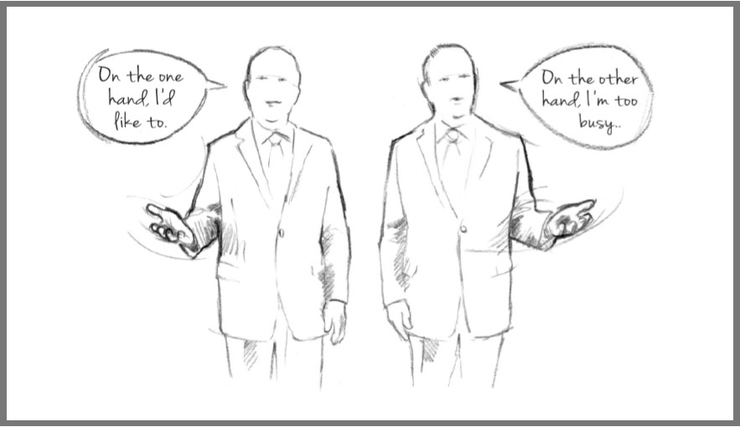

Figure 1. On the one hand, I’d like to. On the other hand, I’m too busy.
However, O1H-OOH is not the only expression to invite this type of symmetrical, side-to-side pattern in the body. Rather, the conventional bilateral demonstration of alternatives is also seen with linguistic expressions that do not make explicit reference to the body, such as in the case of polar adjectives good and bad noted above. Be they alternatives in the realis or irrealis domains or choices along the discourse path, what unites this spectrum of contrast expressions is the fundamental availability of two options – a binarity that is mirrored in the human body. As a three-dimensional entity in the physical world, the body has two sides, a front and back, two hands, arms, shoulders etc. These body parts are most free to move in a binarily constrained set of directions: hands move left or right, towards the body or away from the body, up or down; shoulders move up or down, eyebrows raise and lower, heads tilt left or right and nod up or down. The binarity inherent in each articulator’s movement patterns makes the body particularly effective in expressing the cognitive construct of contrast.

Embodied contrast: Co-speech behavior
I use the term co-speech behaviour to refer to bodily movement that is temporally and semantically aligned with speech. While the field of gesture studies has largely limited its purview to manual gesture, co-speech behaviour refers to articulations beyond manual gesture to include head nods, shoulder shrugs, and other meaningful movements in an interactional context. Such behavior is created in the moment and as such has been described as spontaneous and idiosyncratic. The same form used in different contexts could have quite independent meanings, functioning “now in one way, now in another” (Kendon 2004: 225). However, despite their ad hoc nature, gestures and other articulator movements have also been shown to be highly conventionalized. Recurrent forms of manual gestures are linked through gesture families, which unite form and function (Kendon 2004; Ladewig 2014; Bressem and Müller 2017; Wehling 2017). Studies of the conventionalized forms and functions of other articulators include investigations of shrugs from a form perspective (Debras 2017) and as markers of obviousness (Jehoul et al. 2017).
Signs, specifically gestural signs, can signify through different processes, and it will serve the discussion to briefly review some terminology here. Peircean semiotics and the nature of sign-object relations have been integrated into gesture research by many over recent decades (Mittelberg 2019a: 2; see also Andrén 2010; McNeill 1992, 2005; Mittelberg 2008, 2019b). Peirce identified a three-part distinction between icon, index, and symbol. In this triad, icon reflects a similarity relationship, index a contiguity relationship, and symbol a relationship through conventionality. Much of the focus in gesture studies has centered on manual gestures and on the ways in which they offer a nonarbitrary link between symbol and referent; that is, on the ways they are depictive (Peirce’s icon). For example, a speaker who is telling a story in which she is driving somewhere may convey the conceptual image of driving by holding her hands in the air as if on an imaginary steering wheel. In this case, the action of holding a steering wheel provides the salient representation to evoke a driving frame. Thus, in this case, the speaker’s gesture of holding a steering wheel evokes the experience of driving a car, the existence of the agent/driver, objects with which the driver shares a contiguity relationship (e.g. the steering wheel), and other features of cars, roads, etc. The data presented below include highly recognizable iconic gesture forms, such as the palm-up-open-hand gesture, which has been shown to enact functions of giving, receiving, and presenting (Müller 2004), and the container form, which is motivated by such conceptual metaphors as categories are containers, and ideas are objects (Lakoff and Johnson 1980). However, gestures and other co-speech behaviours also create reference through more abstract or schematic mechanisms. This study extends the discussion to more schematic forms of signaling in the other body parts, such as a head tilt from one side to the other. I suggest here that these forms are equally non-arbitrary and should be seen as meaningful gestural signals in the contrast enactments in which they occur. When compared to the more imageable representations available given the affordances of manual gesture (hands can change shape, orientation, and direction), these upper body signals are more schematic, but, I would suggest, are equally integral as indicators of the cognitive processes at hand.
The second element in Peirce’s triad of ways that signs denote objects is through indexicality. In speech, prototypical indexical signs include deictic expressions (e.g. demonstratives such as this, that, this one, that one), adverbs of time and place, and social deixis. In gesture, the discussion of indexicality usually centers on pointing gestures (McNeill 1992; Kita 2003; Cooperrider and Núñez 2012; Fricke 2014). However, it is important to keep in mind that the triad is not intended to be exclusive (Mittelberg 2008). Rather, all three processes of denotation – iconicity, indexicality, and conventionality – may be active in any given sign. As the data below will show, an iconic gestural form may also serve an indexical function and be highly conventional.
A final important contribution to our understanding of embodied contrast comes from sign language research. Winston (1995; 1996) discusses the functions of spatial mapping strategies by signers. Beyond having a referential function, space is also used to structure discourse. Winston describes the discourse structure of comparative spatial maps in ASL as follows:
The signer usually introduces the two entities to be compared without using a spatial map, then proceeds to build a spatial map to make the comparison. The signer accomplishes this by pointing first to the non-dominant side of the signing space to refer to the first entity. She then points to the dominant side to refer to the second entity. The second entity … is often the focus of the comparison. The signer continues to refer to the two entities by pointing to the two areas on the spatial map, comparing them throughout the discourse.
(Winston 1996:10)
Research on viewpoint and real space blends in ASL has further detailed the use of space in expressing grammatical and conceptual information in ASL. In his discussion on viewpoint and comparative spaces, Janzen notes that in using comparative space mapping, the signer “does not use body shifts towards each space for the purpose of portraying the vantage point of either referent on a scene, but rather to list and describe attributes of each while maintaining the role of ‘informer’ in the discourse” (2012: 168). These uses of space in ASL are worth keeping in mind, as we see similar building and indexing of space in co-speech behavior aligned with contrast.

Contrast and Opposition theory
Semiotics has long been engaged in the theorizing of difference and opposition and exploring the roles these play in structuring meaning (see surveys in Nöth 1994 and Danesi 2009). The origins span from Aristotle’s logical dualism (Ogden 1932) to Saussure’s (1916) notion of différence, which in the 1920s led Prague School linguists to base their approach to language structure in opposition theory. Opposition and différence are closely related notions in structuralist semiotics (Nöth 1994: 37). For Saussure, différence was inherent to semiotic structure and captured the necessity of otherness. Most relevant to the study presented here is Saussure’s notion of difference among concepts, which he described as follows: “Concepts are purely differential and defined not by their positive content but negatively by their relations with the other terms of the system. Their most precise characteristic is in being what the others are not” (Saussure 1916: 117). Work within semiotics on opposition theory has been revived somewhat in recent decades. For example, Danesi and Perron’s (1999) model of interconnectedness in culture and cognition includes implicit reference to opposition in their use of image schema theory (up/down, closed/open). In looking at how single binary opposition might be encoded in a cultural system, Danesi suggests that the binary opposition right / left “is derived, anatomically, from the fact that we have a left hand (and foot, leg, ear, and eye) and a right one” (Danesi 2009: 29). This aligns with original scholarship in cognitive linguistics (Johnson 1987, Lakoff and Johnson 1999), and recent work in embodied cognitive science (Bergen 2012) and semiotics (Danesi 2009; Pelkey 2017) that concurs on the central role of the body and our experience in the world in driving linguistic and conceptual structure.
In this paper, I use the term contrast to capture the general conceptual notion of oppositionality, not restricted to binary opposition. As I show here, however, the co-speech behaviour of the body frequently suggests that the speaker perceives contrast as binary, whether the difference is directly oppositional or not. For example, take the utterance shown in Figure 2.
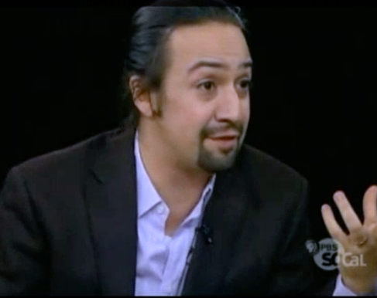 | 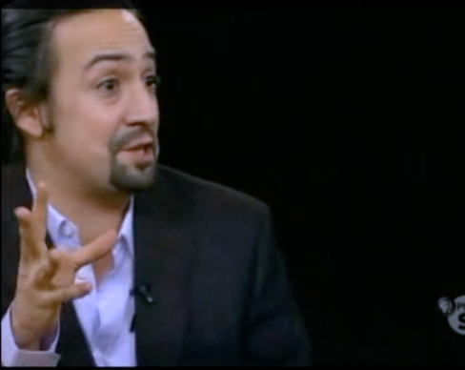
S: Every biography either is insanely defensive  of him | or vilifies him
G: left hand gestures to the left, palm-up container form | right hand gesture to the right, palm forward with outstretched fingers

Figure 2. The setting up of contrast between insanely defensive of him and
vilifies him with bilateral gestures
Two options are given for how biographies, the grammatical subject in the sentence, handle the person that is the subject of the biography: they either are insanely defensive of him or vilify him. Each option fills a slot in the either/or construction. Now, to be defensive of someone and to vilify someone are not oppositional antonyms. However, due to their use in the either/or construction together with the manual gestures that anchor each of these options in opposing space on the speaker’s left or right side, they are coerced into an oppositional relation. In other words, the linguistic and gestural cues together make manifest the conceptual structure in which the speaker views these elements as opposed. Thus, in this paper, I examine how language and the body together manifest a conceptual comparison between two (in some way) opposing forces. The questions of interest are therefore oriented towards describing the full range of resources drawn upon by the speaker-gesturer to embody contrast, rather than towards the theory of opposition itself. However, given the range of linguistic devices and kinesic profiles that are demonstrated, it is hoped that the material will serve theory building regarding difference and opposition. The detailed analysis should further serve as a jumping off point for new methodologies and studies for “identifying meaningful cues in the physical forms of signs” (Danesi 2009: 11), where physical form includes co-modalities such as speech and gesture.

Summary
In this paper I examine the expression of contrast in North American English in the real world, in hypothetical scenarios, and in discourse structuring. I describe a range of bodily and linguistic resources that are recruited to mark contrast and examine the types of semiotic relationships that are at play in the dynamic multimodal signs (i.e. speech/gesture constructions). In describing the enactments of contrast, I aim to demonstrate that, while the marking of contrast in the body is not obligatory, it is certainly not arbitrary. In fact, when analyzed across the propositional, cognitive, and discursive domains, the ways in which contrast is marked in the body can be viewed as a continuum of highly imageable to highly schematic kinesic shifts. By placing the primary focus on the multimodal sign, this paper makes clear how speakers of North American English build semiotic environments around the construal of contrast. It is hoped that the methods and analysis presented here will contribute to a wider discussion of the importance of analyzing co-modalities of speech and gesture, as well as proposing new methods with which to investigate the claim of opposition theory that “binary oppositions underlie basic cognitive and linguistic processes” (Assaf et al. 2015: 159; Danesi 2007).

Methods

Data collection
The data for this study were collected using the archive and facilities of the Distributed Little Red Hen Lab (hereafter Red Hen), co-directed by Francis Steen and Mark Turner (Steen and Turner 2013). This is a massive archive of primarily American broadcast television. The core dataset for Red Hen is the NewsScape Library of International Television News, and the data were accessed online using the Red Hen’s tool, the Communications Archive Edge Search Engine. At present, Red Hen consists of over 400,000 hours of audiovisual data from public broadcasts. This represents circa 5 billion words of closed-captioned text, which can be searched by text string or regular expression searches. It contains a wide variety of genres, from news broadcasts to talk shows, late night comedy shows, and advertisements. Only spontaneous interactions were accepted into the present study. In cases where a search result stemmed from a scripted show, prepared news report, political speech, or other prepared, non-dialogic genre, the data point was excluded from the study. The data set includes TV programs broadcast between November 2012 and November 2016.

Data annotation
Searches were conducted by entering linguistic target phrases into the Red Hen search engine. Red Hen then returns a link to a video that contains the target phrase. Each video clip was viewed for about 20 seconds (or more if warranted) on either side of the target utterance. After assessing that the context met the criteria for unscripted, interactional speech, each clip was viewed for whether there was body movement aligned with speech, i.e., was there co-speech behaviour that was temporally aligned with the utterance, and was the movement differentiated from the previous and following utterances. For all instances with movement, two annotation passes were completed. On the first pass, the involvement of each articulator (e.g. hands, head) was annotated as yes or no. On the second pass, in all cases where there was movement of an articulator, the movement was coded as per the annotation schema shown in Table 1. This annotation schema follows widely adopted practices in gesture studies (Kendon 2004; Bressem 2013; Debras 2017; Hinnell 2018).
Table 1. Variables and levels of kinesic movement annotation
Modality | Variable | Levels
Gesture | Gesture space | core, left of body, right of body
 | Axis | vertical, lateral, sagittal, none (e.g. wrist turn only)
 | Direction | up, down, left, right, diagonal, towards body, away from body, none
 | Hands | left, right, both
 | Form | PUOH, container, palm down, etc.
Head | Movement type | nod, tilt, shake, other
 | Direction | left, right, up, down (if relevant given movement type)
Shoulders | Direction | up, down
Eyebrows | Direction | raise, lower
Torso | Direction | left, right, forward, back, other (e.g. back and left)
All | Partitioning | G (gesture only), G&UB (gesture and upper body), UB only

Contrast in the propositional domain
The expression of contrast in the propositional domain is a very robust phenomenon. Table 2 shows an ad hoc list of the kinds of expressions that do contrastive work in English. To give an indication of the relative popularity of these expressions in everyday speech, the table provides frequency in the spoken portion of the Corpus of Contemporary American English (COCA) (Davies 2008), taken for the purposes of this research to be a proxy for the same dialect and register of English that dominates in Red Hen, spoken North American English. The COCA spoken corpus contains 118 million words collected from 1990 to 2017 (Davies 2008). These figures are intended to indicate relative frequency by expression, rather than to have significance as compared to the total size of the corpus
Table 2. Contrast expressions in the propositional domain:
frequency in COCA_{sp}
Expression | Frequency in COCA_{sp}
SEMI-FIXED EXPRESSIONS
On (the) one hand… | 1,718
On the other hand... | 4,444
On the one side… | 700
OPERATORS
versus | 3,166
LEXICON (collocates within n=9)
David…Goliath | 104
rich… poor | 443
better… worse | 646

O1H-OOH is the archetypal expression for contrast, from both a linguistic perspective and a gestural one. In this section I introduce the primary enactments that accompany this fixed and idiomatic expression. I also show that similar gestural and co-speech behaviours characterize the expression of other bipartite expressions such as In one way… It is also…. From there I describe gestures associated with lexical expressions of contrast such as antonym pairs (David and Goliath, offense and defense) and noun phrases linked by the adverb versus. What is most notable about the enactments observed in the propositional domain is that they are highly conventionalized and highly imageable. That is, the recurrent forms of these enactments have recognizable iconic motivations. Contrast gestures make use of lateral space and symmetrical hand forms to mark an evaluation of binary options. Following the investigation of propositional contrast, in section (4) we observe expressions that inhere to the cognitive and discursive domains and identify bodily enactments that dominantly recruit other articulators, e.g. head movement, in a more schematic means of representing contrast.

The archetype: On the one hand… On the other hand…
Let us first look at the gestural enactment of the archetypal contrast expression in English. The examples of O1H-OOH presented in (V 1) and (V 2) feature the palm-up-open-hand gesture. In (V 1), the host of the Late Late Show, James Corden, utters the following:
- Like, on the one hand, Trump has made a lot of offensive statements. On the other hand, Trump is his party’s only chance at winning.
Aligned with on the one hand, Mr. Corden raises his right hand in a PUOH gesture with relaxed, slightly bent fingers. When he articulates on the other hand, he raises his left hand in the same hand shape to yield the final gestural form shown on the right in (V 1). The PUOH gesture is performed in a similar fashion in (V 2), though here the speaker lowers her right hand before raising her left hand.
(V 1),
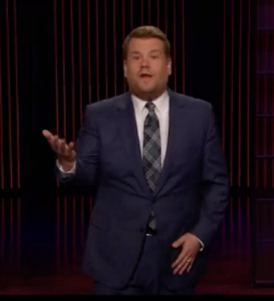 | 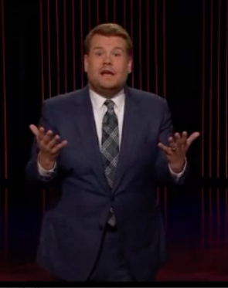
S: Like, on the one hand Trump has made a lot of offensive statements … | On the other hand, Trump is his party’s only chance at winning.
G: right hand raised in PUOH | left hand rises to match right hand in PUOH

(V 2)
 | 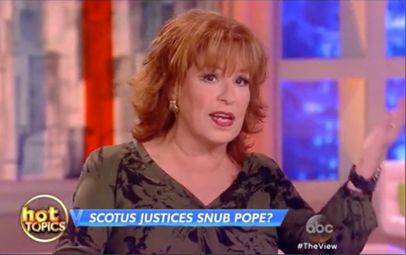
S: Apparently they like him on both sides. On the one hand he believes in climate change so they consider him a Liberal. | On the other hand he doesn’t believe in abortion so they consider him a Republican…
G: right hand PUOH | left hand PUOH

Several elements in these gestural expressions contribute to the enactment of contrast. Firstly, the gestural signs shown here are strongly iconic. The PUOH provides a metaphoric representation of ideas that are in, or on, the hand and are being presented or displayed. In (V 1), for the first part of the gesture the hand is open and relaxed and could be seen to be supporting (or ready to support) an imaginary object. In the second part of the gesture, both hands are flatter with fingers more extended. As such they mimic the presentation of an object for inspection. Müller (2004: 233) describes one function of PUOH as “present[ing] an abstract discursive object as an inspectable one – an object which is concrete, manipulable, and visible, and it invites participants to take on a shared perspective on this object”. Thus, in (V 1), the PUOH sequence begins with a presentative gesture in the first part of the gesture phrase and proceeds to a final hold that simultaneously presenting both alternatives for consideration in the final hold of the gesture. In (V 2), by contrast, each option is only ever presented one at a time.
We also observe the embodiment of contrast in the way in which the hands bifurcate the speaker’s gesture space. In both (V 1) and (V 2), the speakers first place their right hand in the PUOH form to the right of the body, and the left hand then indexes an opposing space on the left side of the body. In conjunction with the speech content, these gestures serve to build two contrastive spaces. The speaker-gesturer simultaneously builds alternate spaces in the physical-spatial realm around his/her body and uses these spaces referentially. In (V 2), in addition to the PUOH on each side, a head tilt is aligned with each gesture, underling the indexing of space in the manual gesture. Finally, the physical distance between the two spaces iconically manifests the difference between the ideas, a mapping in which conceptual distance corresponds to physical distance.
Of course, given the nature of gesture formation as both spontaneously innovative and structured by convention, not all gestures aligned with O1H-OOH take the form of a bimanual PUOH gesture. A second dominant profile for O1H-OOH consists of container-like gestures. The container forms shown in (V 3) and (V 4) show two instances of the representation of a metaphorical holding of an idea, where the idea that is being ‘held’ is the proposition that follows on the one hand. In these utterances, the gestures also demonstrate an indexing of space. Both of the speaker-gesturers move their hands in the container form to one side as they speak (in V 3 the gesture moves to the right, in V 4 to the left). Thus, while the container form metaphorically represents the notion that is being contrasted, the displacement of hands in space serves an indexing function by placing the idea in an alternate physical space.
(V 3)
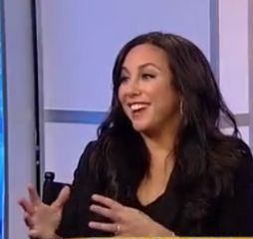
S: Yeah. I mean, on one hand, I was trying to tell the hopeful story, because years ago, he couldn't even run.
G: container, centre of body

(V 4)
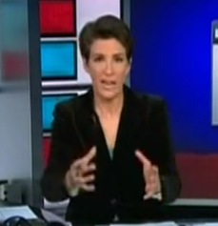 | 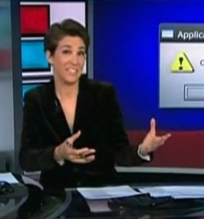
S: On the one hand | it’s kind of exciting to be talking Iraq
G: container, centre of body | hands move to speaker’s left, relaxing of container handshape

The use of eyebrows in (V 4) is also notable. Eyebrow raises have been shown to co-occur frequently with topic marking and to function as emotive markers (Ekman 1993). Topic-marking inherently performs a contrast-marking function; a new topic necessarily represents a shift from the previous topic. Given that the functions of eyebrow raises are many, I leave open whether in this example the eyebrow movement can be delineated as emotive or contrastive in meaning. Importantly, this example illustrates the possibility that different types of contrast are layered in the same enactment. For example, while in (V 4) the bilateral marking of space in the hands is clearly indexical – building a space that the gesturer can then reference, the eyebrows mark the affective stance of the speaker as communicated by the hedge (kind of exciting). The eyebrow raise could also be co-indexing the alternativity in the proposition. Given the kinesic limitations of eyebrow movement to the vertical axis, the indexing is necessarily more schematic when compared to the hands, which can place an index in physical space to one side or the other of the body.
The indexical function of gestures of contrast also manifests in a range of pointing gestures. Pointing gestures create a relationship between the tip of the articulator (the finger or hand, depending on the handshape used) and the real or imagined object, or target, of the point. They serve the function of a placeholder or “placing index” (Mittelberg and Waugh 2014: 1755). They can include instances with a point in the hand form as in (V 5), while other gestures indicate towards space using more neutral hand shapes as in (V 6). In the cases of O1H-OOH that are accompanied by pointing gestures, the points make the indexical use of space even more explicit than when the gesture is in the form of a PUOH or container placed on either side of the speaker, as seen in the earlier examples.
In the scenario captured in (V 5), the speaker is reporting the contrast between the principles of civility and discourse that the unnamed third person stands for, and this person’s actions, which go against those principles. The text of the full utterance is shown in (3).
- You know, as we listen on the one hand, that he talks about civility and discourse and jumps into the Rush Limbaugh controversy, but takes a million dollars from Bill Marr, lectures on the one hand, his surrogates attack on the other hand, he attacks on the other hand. What are we to make of what this says about the president?
For each item that the speaker lists (the underlined segments in (3)), he uses a point hand shape and indicates to one side or the other. This results in a sequence of four shifts from side to side, each of which is aligned with the shift from one enumerated item to the next. Here, again, there is a layering in the body that creates a composite signal. In addition to the gestural points, a head tilt aligns with each alternating point to clearly co-index and refer to the space that is built for each option throughout the sequence. The involvement of the head in co-indexing space is unsurprising, as the head is known to be used cross-culturally in points (Cooperrider 2018; Cooperrider and Núñez 2009). A more muted example that nonetheless shows the indexing of space in the expression of contrast is the bimanual open-palmed gesture shown in (V 6). Here, both hands are outstretched rather than taking the form of a finger point.
(V 5)
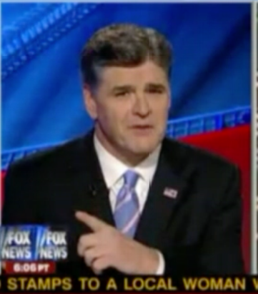 | 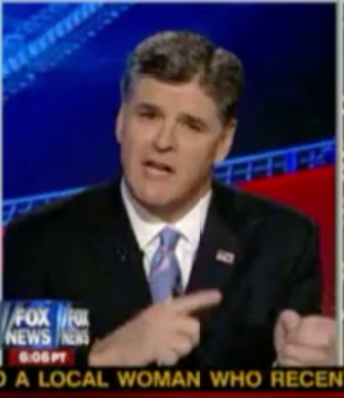 |  | 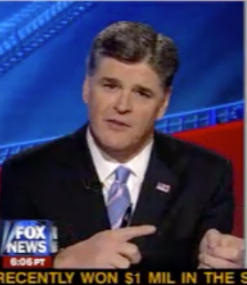
S: …takes a million dollars from Bill Maher, | …lectures on the one hand, | …his surrogates attack on the other hand, | …he attacks on the other hand…
G: bimanual point to speaker’s right | point and head tilt to speaker’s left | point and head tilt to speaker’s right | point and head tilt to speaker’s left

(V 6)


S: Paula, I think, on one hand, we can expect if we found one piece of debris, that there are probably others with it.
G: open flat hand, palms facing, to left side of body

Before moving on to other bipartite expressions that mark contrast, I provide here a summary of the annotations for O1H-OOH. Firstly, regarding the degree of enactment (the percentage of instances that were aligned with co-speech behavior), 71% of on the one hand were co-articulated in the body, while 77% of instances of on the other hand were enacted. This shows that O1H-OOH is highly enacted in the body. The profile of these enactments is shown in the summary of annotations in Table 3. Manual gestures certainly dominate the expression of O1H-OOH, with container and PUOH forms being the most frequent. For on the one hand, 19/20 featured manual gesture (14 gesture only, 5 gesture and upper body) and on the other hand was gestured in 18/20 instances (6 gesture only and 12 gesture and upper body). As these figures show, particularly for O1H, the upper body is also active (6 total for O1H, 14 total for OOH). These upper body movements consist largely of head and eyebrow movements.
Table 3. Summary of annotations for O1H-OOH
Modality | Variable | On the one hand (O1H) | On the other hand (OOH)
Gesture | Gesture space | 11 centre, 3 left, 5 right of body | 9 centre, 3 right, 4 left  (2 outside core)
 | Axis | 8 vertical, 5 horizontal, 5 diagonal | 3 vertical, 12 horizontal, 2 diagonal
 | Hands | 11 bimanual, 5 right, 2 left | 11 bimanual, 4 right, 3 left
 | Form | 10 container, 6 PUOH, 1 palm down, 1 vertical hand | 2 PUOH, 2 p-down, 2 points, 2 vertical hand, 1 container
Head | Movement type | 3 tilts, 1 nod, 1 shake | 6 tilts, 6 nods, 1 turn
Shoulders | Direction | 3 up/down | none
Eyebrows | Direction | 2 brow raise | 4 brow raise
Torso | Shift | 1 shift | 3 shifts
All | Partitioning | 14 G, 5 G&UB, 1 UB | 6 G, 12 G&UB, 2 UB

Other phrasal expressions of contrast
O1H-OOH is not the only bipartite expression that yields this profile in the co-speech behaviour. Rather, speakers rely on other linguistic devices to create bipartite expressions that mirror the O1H-OOH structure. The frequency data from COCA_{sp} (Table 2, above) indicated that for 1,718 instances of on the one hand, there were 4,444 instances of on the other hand. Further investigation in the corpus yielded two reasons for this disparity. Rather than always occurring in the O1H-OOH bipartite expression, both parts of the expression can be combined with other semi-fixed phrases. That is, O1H can be followed by a resolution phrase other than OOH, as shown in (4) and (5). Alternatively, OOH can be set up by an expression other than O1H as shown in (6), or can occur without an overt maker in the upstream utterance, as shown in (7).
- How do you protect the borders on the one hand and at the same time have a real earnest fair conversation about meaningful immigration reform?
- On one hand you want to support the kid but when they enter into the real world, you don’t get a trophy.
- So I hear your point about not overstating the importance of good music and good songwriting. On the other hand, the boundless and endless joy that we experience because of music and the place that we come to appreciate because of good music.
- We think of issues and we want a more sophisticated approach. On the other hand, this is the second phase of the campaign. The summer is the fun part….
In addition to these alternatives to the full O1H-OOH expression, speakers use alternate devices in the same bipartite phrasal construction, such as in (8).
- It is in one way very exciting that this is finally a matter of high-level political discussion. It is also at the same time very disconcerting to see the Republican Party …
However, results of the annotations show that the bodily enactment of these variants is not discernibly different from those for O1H-OOH shown to this point. This is not surprising given the underlying cognitive construct, the parallel linguistic structures, and the propositional domain to which they all inhere. This is demonstrated in the gesture sequences in (V 7) and (V 8). In (V 7) the use of space and PUOH hand shape mirror the profile of (V 1) and (V 2) above, while (V 8) combines an initial container gesture (as in V 3 and V 4), indexed on the left, which is held as the alternate space is indexed on the right.
(V 7)
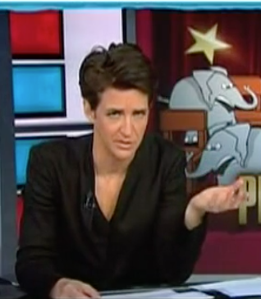 | 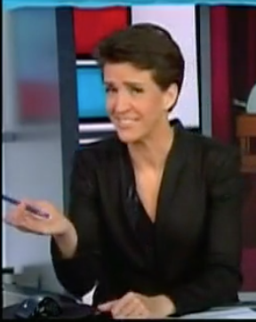
S: Donald Trump’s expected visit to Arizona tomorrow, it will spark protests tomorrow. It’s already sparking consternation amongst some leading Republicans in Arizona. | But on the other hand, it’s the Maricopa County that invited him
G: PUOH (cupped) with left hand | PUOH (holding pen) with right hand

(V 8)
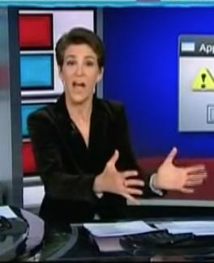 | 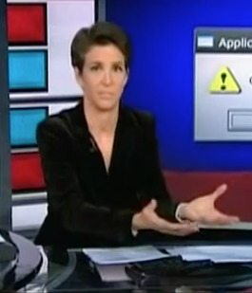 | 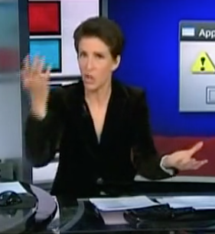 | 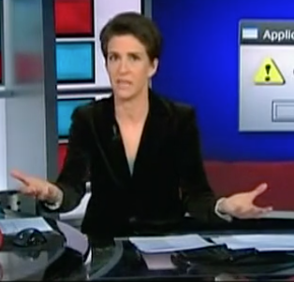
S: It is in one way very exciting that this is finally a matter of | high level political discussion. | It is | also at the same time very disconcerting to see the Republican Party …
G: bimanual container gesture on speaker’s left | bimanual PUOH on speaker’s left | (transition: moves right hand from left to right side) | bimanual PUOH

Lexical expressions of contrast
Contrast in English is also expressed lexically. Lexical items that mark contrast can include comparative adverbs and adverbial phrases (e.g. better/worse, better than/worse than), antonymic nouns (e.g. David/Goliath, defense/offense), and noun phrases linked by an adverb such as versus. In data gathered in a 3D motion capture experiment that was designed to elicit discourse on the topic of habitual events, one participant compared her habit of nail biting to the severity of other peoples’ nail biting habit. This is shown in (V 9). The participant indicates that she does bite her nails (I think that that is something I still do) and contrasts this with the degree to which other people do it (there are lots of people who do it way worse). At the same time as uttering these remarks, she indexes the space to the right of her body to mark her own habit, and subsequently places the nail biting of other people on the left side of her body. In this construction, it is both the person (I vs. other people) that is contrasted, as well as the degree to which the speaker and these persons bite their nails. In a similar mapping shown in (V 10) below, from the Red Hen data, the lexical antonyms offense and defense are indexicalized on alternate sides of the body by means of both manual gesture and a head tilt (particularly to indicate offense in the screenshot on the right).
(V 9)
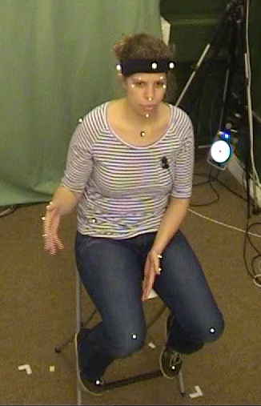 | 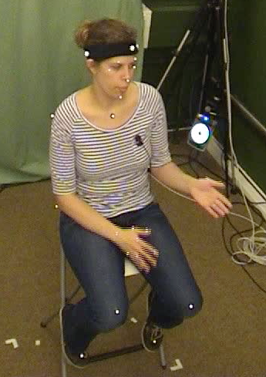
S: I think that that is something I still do | there are lots of people who do it way worse
G: palms towards each other, arm movement to speaker’s right | same motion to speaker’s left

(V 10)
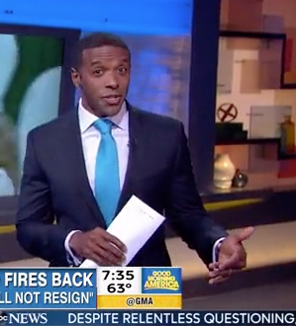 | 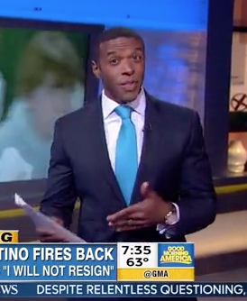
S: Rick Petino playing some defense | by going on the offense
G: cupped hand gesture to left side | same hand points, moves to right
This pattern also characterizes contrast marked by noun phrases as in (V 11). Though the phrases Republican news network and frontrunner Republican presidential candidate are not inherently antonymic, contrast is achieved through the use of the linking adverb versus in the linguistic expression, and the concomitant use of space to anchor each player in the scene in space on opposite sides of the speaker’s body.
(V 11)
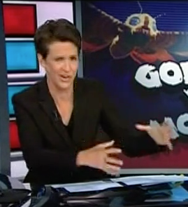 | 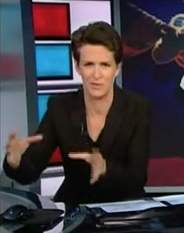
S: Republican news network versus | frontrunner Republican presidential candidate
G: bimanual container gesture left of body | bimanual container gesture right of body

Following the sequence in (V 11), after placing each noun phrase in its own space to each side of her body, the host closes the contrastive statement with the utterance in (V 11b). She holds both hands in the air and moves them up and down at the same time (i.e. one hand moving up while the other moves down, and vice versa). She thus maintains the indexicalized meaning she has placed in each hand and on each side; it is clear to the viewer which referent is referred to by each hand while she compares their size. (From a multimedia perspective, the comparison the speaker articulates is highlighted by the projected text behind her referring to the 1992 Japanese science fantasy Godzilla vs. Mothra).
(V 11b)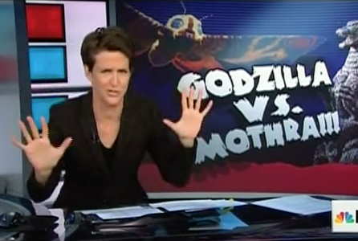
S: two monsters of roughly the same size
G: bilateral palms forward, one on each side
To summarize thus far, in this section I have shown how contrast is enacted in English when it is expressed by the prototypical O1H-OOH, in expressions that are set up in a similar bipartite syntax, and finally in lexical expressions. Contrast is embodied regularly through bimanual PUOH gestures placed sequentially on each side of the body, by container gestures, by points, and also through co-aligned head tilts in some cases. For the most part, the enactments indexically mark space by referring with the hands (and occasionally the head) to first one side and then the other. These enactments create highly imageable representations of a comparison of objects or ideas. In the next section, I illustrate the marking of contrast in the cognitive and discourse domains, and suggest that here, too, the enactments show the same mechanisms at work. However, in these domains enactments of contrast are predominantly expressed in the upper body rather than in manual gesture. By nature of the articulators used, these enactments are more schematic, but, I would suggest, no less iconic, expressions of contrast.

Contrast in other domains
In the previous section, I illustrated enactments of contrast in the propositional domain that were expressed through fixed or semi-fixed bipartite phrases and word-level constructions. Most of the examples were of actual events in the ‘real world’ and thus could be considered to be relatively objective. In this section, I present, albeit more briefly, contrastive utterances in two other domains, namely in the cognitive and discursive domains. In the cognitive domain, linguistic expressions of contrast include modal verbs, negation, and conditional constructions. Each of these devices has been shown to be involved in building alternate mental spaces (Dancygier and Sweetser 2005). In these cases, contrast generally arises from mapping each alternate space to a location in the speaker’s gesture space. In a discursive domain, I give examples of contrast arising from a shift in the discourse direction, usually expressed in speech by discourse markers such as the concessive markers anyhow, but anyways, however, etc. (Biber et al. 1999).
In comparison to the more iconic and overt depictions of contrast shown in the previous section, the examples from the cognitive and discursive domains presented in this section feature a subtler, more schematic signaling of contrast in the body. What remains constant are that the contrast is marked, and that the co-speech behaviours serve one of the same functions seen in the propositional domain, namely to setup alternate spaces and then to refer to these spaces. However, the corpus data suggest that it is primarily the upper body that is recruited to do this work, for example through shoulder shrugs and head tilts. In comparison to the rich affordances of the hands to aptly express propositional contrast through both form and placement of a manual gesture, for kinesic reasons, this range is not available to upper body articulators. Rather, in the upper body, articulators generally move in a smaller range of ways (e.g. the head can nod, tilt or shake, shoulders can move up or down). As the data in this section suggest, however, speakers are adept at expressing contrast in the cognitive and discursive domains. We must simply expect that it looks different given the different kinesic movements available to the upper body.
The scenario in (V 12) captures an utterance in a highly subjective mental space, what I refer to as the cognitive domain. The speaker asks herself what an appropriate response would be to a situation she is presented with. The text features numerous markers of stance – rich in modal, interrogative, and conditional markers. For context, the full text of the utterance is given in (9).
- Wow, should I be flattered? Should I be outraged? Should I be insulted?
Is this… Should I do it? Should I not do it?
Well, if I did it, what would it look like? You know.
And I mean, these are new kinds of things for anybody to have to think about.
Throughout the utterance, the speaker constantly shifts her upper body. That is, each alternative is enacted with a commensurate shift in one or more articulators: her head tilts, her eyebrows raise and then lower, her shoulders move upwards and then downwards, and her gaze shifts strongly to the side, and also upwards. The effect is that the speaker-gesturer creates a constant marking in her body of each of the alternatives that she is comparing in her speech. The use of gesture is minimal, with hand movement seen only in the final rhetorical question underlying the utterance, Well if I did, what would it look like?, as shown in the final pair of screenshots. Even here, the hand shape is not fully formed. Rather, a loosely held palm towards the speaker relaxes into a palm-up gesture on the final question.
Let us look in more detail at the first series of expressions (V 12a), in which the speaker enumerates possible emotional responses to the scenario she finds herself in: Should I be flattered? Should I be outraged? Should I be insulted? In her co-speech behaviour, with each enumerated item the speaker tilts her head, first to her right, then to her left, then returning to neutral. She also maintains an upwards gaze, which returns to neutral when her head does. Thus (V 12a) shows that the speaker enacts the difference between each conditional space. In Section 3, I proposed that when gestures are first placed on one and then on the other side of the body, the sequence creates meaning by simultaneously building and indexing a contrastive space on each side of the body. I suggest that the series of head tilts in (V 12a) serves the same function, namely, to create and reference alternate spaces.
Turning to the second series of screenshots (V 12b), the movements that accompany the utterance of Should I do it? Should I not do it? are also of interest. Several upper body movements are involved in this sequence. The first part of the utterance is aligned with a movement of the shoulders and eyebrows upwards and a glance to the left, while the alternative Should I not do it? is aligned with a downwards movement of the shoulders, a head tilt and eyebrow movement downwards. Thus, these two composite gestures differ in binary ways: the shoulders and eyebrows move up, and then the same articulators move down. In the spoken utterance, the contrast is marked overtly by negation – indeed from a syntactic perspective, that is the only difference between the two parts of the utterance. In the mental spaces framework, negation has been described as the “primary example of alternativity” (Dancygier 2012: 69). “The negative particle not is thus said to set up two alternative spaces, rather than just one: the negative space described in the sentence and its positive alternative” (ibid) (reminiscent of difference in the Saussurean sense). Here, the alternativity motivates not only the spoken utterance, but can also be seen to motivate the kinesic form.
The side-to-side shifts continue as the speaker utters the final conditional, introduced by the if-statement (Well, if I did it…) shown in (V 12c). In this case, in addition to the postural lean and head tilt to the right and then the return to neutral, there is a shift in hand position. The gesture form moves from the hand facing the speaker to an upwards-oriented hand position. The shift towards a PUOH-like hand form could indicate a presentation of the rhetorical question what would it look like? The key point, however, is that every shift in the body enactment parallels a contrast that is co-articulated in the speech stream.

(V 12)
(a)
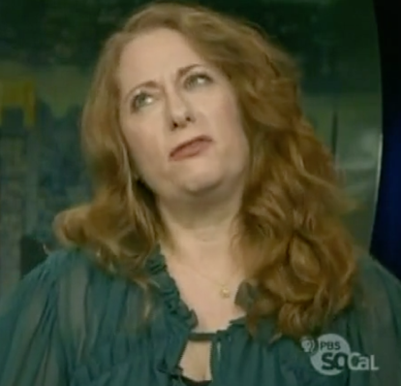 | 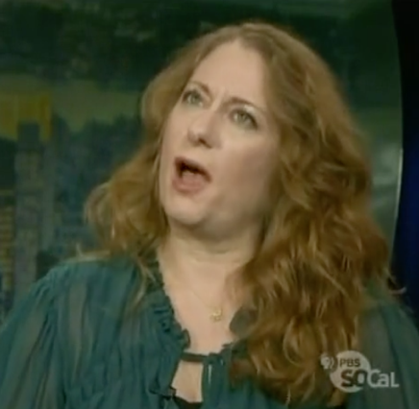 |  | 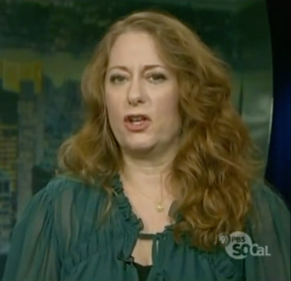
S: Should I be flattered? | Should I be outraged? |  | Should I be insulted?
G: gaze upwards, head tilt right | gaze upwards, head tilt left |  | gaze and head return to neutral
(b)
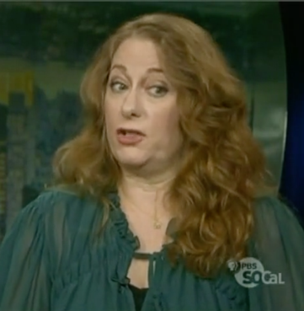 |  | 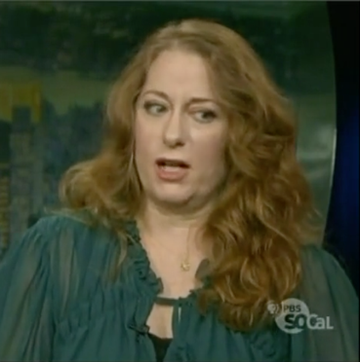
S: Should I do it? |  | Should I not do it?
G: shoulders up, eyebrows up, glance left |  | shoulders, head tilt, eyebrows down
(c)
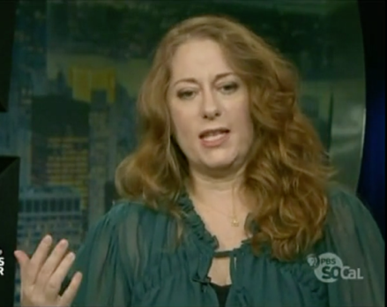 |  | 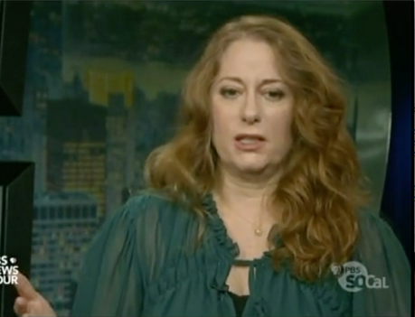
S: Well if I did it… |  | what would it look like?
G: palm facing speaker, head tilt right, right shoulder moves down |  | palm lowered into PUOH, posture tilt back to centre

Now, one could doubt that the sequence in (V 12) is the type of co-speech behaviour that is regularly seen in colloquial speech. Granted, the example does seem to be highly exaggerated. However, an examination of corpus data for other instances of contrast in the cognitive domain yields similar results. In (V 13) we see a pair of contrastive if-statements. The indexing of two alternative spaces – driven by the negation – is achieved through a slight head tilt first to one side then the other.
(V 13)
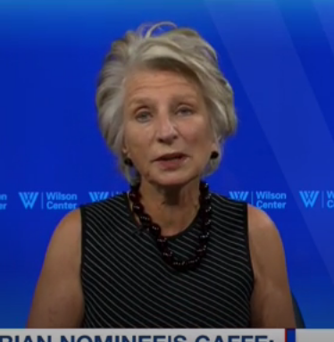 | 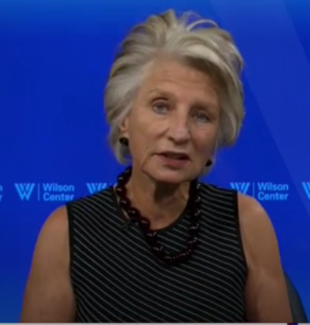
S: If Gary Johnson gets to that level, he’ll be on the stage | If he doesn’t get to that level, he won’t
G: head tilt to right | head tilt to the left

I turn now to the discursive domain. This domain captures the ways in which speakers add stance to their propositional utterances and create cohesion and arguments as they progress along a discourse path. Concessives are one type of linguistic device used to mark these successive shifts throughout an interaction, and many of these have contrastive functions (Biber et al. 1999). To illustrate, I use an utterance that includes the concessive marker anyhow. This marker directs the discourse in a new direction, presenting a disaffiliation with the content that has come in the preceding discourse. As shown in (V 14), this juncture in the discourse can be enacted in the body in similar ways as was seen in the cognitive example presented above. Here, the speaker creates an irrealis scenario introduced by It would be great if…. There is then a distinct head tilt when she utters anyhow. The concessive device returns the speaker (and viewer) to the present, realis, space, in which she goes on to introduce another guest (joining us now…). In addition to signaling that the speaker is moving away from the former topic, it creates a contrast between the irrealis world introduced by it would be great if, and the real world in which this did not occur. The speaker’s mouth shrug here most likely indicates her negative stance towards the content of the irrealis space she has just described. In this way, the composite behaviour of the head tilt and mouth shrug serve to concurrently index the irrealis space (through the head tilt) and to ascribe an evaluation to it (through the mouth shrug).
(V 14)
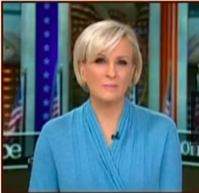 | 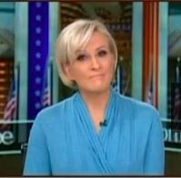 | 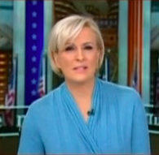
S: It would be great if Mitch McConnell would just say ‘the tweets are no good, we don’t agree with them, they’re inappropriate, and they’re bullying, and we don’t stand by that’. | Anyhow. | Joining us now is the…
G: neutral posture | head tilt to right, mouth shrug | head returns to neutral

In (V 15) we see another example of discourse contrast, this one with the utterance at any rate functioning as the linguistic device that marks the distance to the previous topic. Here, there is a manual gesture in the holding-away form with both palms raised and facing outwards, as well as an eyebrow raise, head raise, and torso shift up, over, and to the right to arrive in the final position shown in the rightmost screenshot. Taken together, this composite gesture creates a full-body shift that iconically represents the directional shift in the discourse context. The postural movement from right to left is the most overt marking of the building of alternate space in this instance, though the eyebrow raise also contributes. The speaker’s rightward position indexicalizes the previous discourse segment, while the subsequent shift to the left places the next topic in the space on the left side of his body. Here, again, we see the mapping of conceptual distance to physical distance in movements of the torso from side to side and in the brow raise (the brow raise up is distanced from the neutral brow position). Lastly, the holding-away gesture also serves a distancing function (Bressem and Müller 2017).
(V 15)
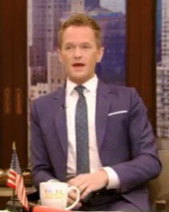 | 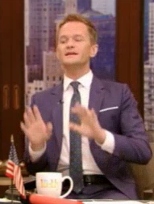 | 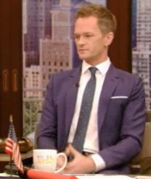
S: (previous segment) | At any rate, | I’m very very happy to be back in the States
G: postural hold to speaker’s right | holding-away gesture, brow raise, head raise, torso shift up and to the left | return to neutral

This preliminary investigation of expressions of opposition in the cognitive and discourse domains suggest that contrast is frequently expressed in the body in these domains, just as it is highly enacted in the propositional domain. The means of marking contrast differ, however, due to affordances of upper body articulators, which render the forms more schematic. I propose that the variability in contrast marking in the cognitive and discursive domains can be accounted for when taken from the perspective of the broader investigation of contrast in the propositional domain. The shifts in head, brows, shoulders, and torso in the examples shown all mark alternative, irrealis spaces and anchor these spaces in real physical space in relation to the body. In this way, many of these movements are indexical. In the discursive domain particularly, these shifts are also iconic, as the speaker makes manifest, with his/her body, the shifts in the discourse itself. While the scope of this paper does not allow a full analysis of cognitive and discourse contrast and the ways in which different articulators combine to produce complex composite signs, such an investigation would constitute an important evolution of the preliminary analysis presented here.

Concluding remarks
In this paper I have shown how the body signals the cognitive construct of contrast across a range of instances in multiple domains. While focusing primarily on utterances comparing two things in the real world, i.e., propositional contrast, I have also provided some comparison with contrast expressions in the cognitive domain, in which speakers consider hypothetical worlds, and in the discursive domain, where speakers indicate a juncture along a discourse path. Across all three domains the analysis has explicated the ways in which speakers enact contrast by anchoring objects, ideas, and mental spaces in physical space. This marking uses the full range of articulators involved in co-speech behavior – from manual gesture, to shoulders, head, brow, and gaze movements. In addition to surveying the types of enactments produced, I have highlighted several semiotic mechanisms that underlie contrast marking in English. The gestures and other body movements display both an iconic grounding in the experience of contrast in the real world that is related to balance and weighing objects as well as an indexical referencing of space within this construct. In the propositional domain, for example, PUOH, container, and pointing gestures map one idea or entity to space on one side of the body and an alternate idea or entity to space on the other side of the body. In the cognitive and discursive domains, head tilts index one mental state and then an alternate mental state, or a new discourse path, respectively. And finally, again in the discursive domain, even a postural movement from side to side indexes a space that is different from the previous discourse space – a physical shift motivated by the discourse shift. I have shown here that, when viewed together, the seemingly ad hoc nature of these shifts in the body can be seen as motivated ways of marking contrast.
Gesture has been referred to as both an “unwitting” window into the mind (McNeill 1992: 12) and as the locus of “partial semiotic portrayal par excellence” (Mittelberg 2019b: 2). Given the highly iconic ways in which gestures represent, to suggest that the enactment of contrast – indeed of any conceptual domain – is grounded in iconic representation in the body (in the broader interpretation of iconic as ‘nonarbitrary’) is not novel. However, in looking broadly across multiple domains, I have shown here just how much of the variation in the co-speech expression of contrast is meaningful. This study has aimed to broaden our understanding of the role of the body in marking conceptual notions, providing insight into cognition and the role of gesture, and crucially, other co-speech behaviour in meaning making. It underscores the need for the inclusion of the full range of kinesic signalling, rather than relying only on the more established examination of co-speech gesture forms, in examining the representation of cognitive constructs in the body. Finally, the methods and analysis used here could be expanded by theorists to explore dominant claims of theories of opposition and difference in semiotics, for example, by using co-speech behaviour to examine differentiations in the kinesic enactment of binary vs. scalar opposition.

Acknowledgements
I am grateful to Jamin Pelkey and two anonymous reviewers for generous and constructive feedback, as well as to Sally Rice and Irene Mittelberg for thoughtful responses to this work as it was developed. I also gratefully acknowledge the Social Sciences and Humanities Research Council of Canada and the Killam Trusts for their support.

Bibliography
Andrén, Mats. 2010. Children’s gestures from 18 to 30 months (Lund: Centre for Languages and Literatures, Lund University).
ASSAF, Dan, Yochai COHEN, Marcel DANESI, and Yair NEUMAN. 2015. “Opposition theory and computational semiotics”, Sign Systems Studies 43.2–3, 159–172.
BERGEN, Benjamin. 2012. Louder than Words (New York: Basic Books).
BIBER, Douglas, and Edward FINEGAN. 1989. “Styles of stance in English: Lexical and grammatical marking of evidentiality and affect”, Text 9.1, 93–124.
BIBER, Douglas, Stig JOHANSSON, Geoffrey LEECH, Susan CONRAD, and Edward FINEGAN, Editors. 1999. Longman Grammar of Spoken and Written English (London: Pearson Education Limited).
BOLINGER, Dwight. 1989. Intonation and Its Uses: Melody in Grammar and Discourse (London: Edward Arnold).
BORKENT, Mike, Barbara DANCYGIER, and Jennifer HINNELL, Editors. 2013. Language and the Creative Mind (Stanford: CSLI Press).
BRESSEM, Jana. 2013. “A linguistic perspective on the notation of form features in gestures”, in Body – Language – Communication: An International Handbook on Multimodality in Human Interaction, Vol. II, ed. Cornelia Müller, Alan Cienki, Ellen Fricke, Silva H. Ladewig, David McNeill, and Sedinha Teßendorf (Berlin: De Gruyter Mouton), 1079-98.
BRESSEM, Jana, and Cornelia MÜLLER. 2017. “The ‘Negative-Assessment-Construction’ – A multimodal pattern based on a recurrent gesture?”, Linguistics Vanguard 3, 1–9.
COOPERRIDER, Kensy. 2018. “Foreground gesture, background gesture”, Gesture 16.2, 176–202.
COOPERRIDER, Kensy, and Rafael NÚÑEZ. 2009. “Across time, across the body. Transversal temporal gestures”, Gesture 9.2, 181–206.
COOPERRIDER, Kensy, and Rafael NÚÑEZ. 2012. “Nose-pointing: Notes on a facial gesture of Papua New Guinea”, Gesture 12.2, 103–129.
DANCYGIER, Barbara. 2012. “Negation, stance verbs, and intersubjectivity”, in Viewpoint in Language: A Multimodal Perspective, ed. Barbara Dancygier and Eve Sweetser (Cambridge: Cambridge University Press), 69–93.
DANCYGIER, Barbara, and Eve SWEETSER. 2005. Mental Spaces in Grammar: Conditional Constructions (Cambridge: Cambridge University Press).
DANCYGIER, Barbara, and Eve SWEETSER, Editors. 2012. Viewpoint in Language: A Multimodal Perspective (Cambridge: Cambridge University Press).
DANESI, Marcel and Paul Perron. 1999. Analyzing Cultures (Bloomington: Indiana University Press).
DANESI, Marcel. 2007. The Quest for Meaning: A Guide to Theory and Practice in Semiotics (Toronto: University of Toronto Press).
____. 2009. “Opposition theory and the interconnectedness of language, culture, and cognition”. Sign Systems Studies 37. 11–41.
DAVIES, Mark. 2008-. The Corpus of Contemporary American English (COCA): 560 million words, 1990-present. Available online at http://corpus.byu.edu/coca/.
DEBRAS, Camille. 2017. “The shrug: Forms and meanings of a compound enactment”, Gesture 16.1, 1–34.
DEBRAS, Camille, and Alan CIENKI. 2012. “Some uses of head tilts and shoulder shrugs during human interaction, and their relation to stancetaking”, Conference proceedings of the 2012 ASE/IEEE International Conference on Social Computing (Amsterdam, 3-5 September, 2012).
EKMAN, Paul. 1993. “Facial expression and emotion”, American Psychologist 48.4, 384–392.
FEYAERTS, Kurt, Geert BRÔNE, Bert OBEN. 2017. “Multimodality in Interaction”, in The Cambridge Handbook of Cognitive Linguistics, ed. Barbara Dancygier (Cambridge: Cambridge University Press), 135–56.
FILLMORE, Charles J. 1982. “Frame semantics”, in Linguistics in the Morning Calm, ed. Linguistic Society of Korea (Seoul: Hanshin), 111–37.
FRAWLEY, William. 1992. Linguistic Semantics (New York: Routledge).
FRICKE, Ellen. 2014. “Deixis, gesture, and embodiment from a linguistic point of view”, in Body – Language – Communication: An International Handbook on Multimodality in Human Interaction, Vol. II, ed. Cornelia Müller, Alan Cienki, Ellen Fricke, Silva H. Ladewig, David McNeill, and Sedinha Teßendorf (Berlin: De Gruyter Mouton), 1803–1823.
HARRISON, Simon. 2013. “The temporal coordination of negation gestures in relation to speech”. Paper presented at the Tilburg Gesture Research Meeting (TiGeR), Tilburg, NL, June 19-21.
HARTMANN, Stefan, Michael PLEYER, James WINTERS, Jordan ZLATEV, Editors. 2017. Interaction and Iconicity in the Evolution of Language. Special issue of Interaction Studies (Amsterdam: John Benjamins), 18.3.
HINNELL, Jennifer. 2018. “The multimodal marking of aspect: The case of five periphrastic auxiliary constructions in North American English”, Cognitive Linguistics 29.4, 773–806.
JAKOBSON, Roman. 1962. Selected writings, Vol. 1, ed. Stephen Rudy (The Hague: Mouton).
JANZEN, Terry. 2012. “Two ways of conceptualizing space: Motivating the use of static and rotated vantage point space in ASL discourse”, in Viewpoint in Language: A multimodal perspective, ed. Barbara Dancygier and Eve Sweetser (New York: Cambridge University Press), 156–176.
JEHOUL, Annalise, Geert BRÔNE, and Kurt FEYAERTS. 2017. “The shrug as marker of obviousness”, Linguistics Vanguard 3.1, 1–9.
JOHNSON, Mark. 1987. The Body in the Mind. The Bodily Basis of Meaning, Imagination, and Reason (Chicago, IL: University of Chicago).
_____. 2017. Embodied Mind, Meaning, and Reason: How our bodies give rise to understanding (Chicago: University of Chicago Press).
KENDON, Adam. 2004. Gesture: Visible Action as Utterance. (Cambridge: Cambridge University Press).
KITA, Sotaro. 2003. Pointing: Where language, culture, and cognition meet (Mahwah, NJ: Lawrence Erlbaum Associates Publishers).
LADEWIG, Silva. H. 2014. “Recurrent gestures”, in Body – Language – Communication: An International Handbook on Multimodality in Human Interaction, Vol. II, ed. Cornelia Müller, Alan Cienki, Ellen Fricke, Silva H. Ladewig, David McNeill, and Sedinha Teßendorf (Berlin: De Gruyter Mouton), 1558–1574.
LAKOFF, George, and Mark JOHNSON. 1980. Metaphors We Live By (Chicago: University of Chicago Press).
1999. Philosophy in the Flesh: The Embodied Mind and its Challenge to Western Thought (New York: Basic Books).
MCNEILL, David. 2005. Gesture and Thought (Chicago: University of Chicago Press).
1992. Hand and Mind: What Gestures Reveal about Thought (Chicago: University of Chicago Press).
MITTELBERG, Irene. 2008. “Peircean semiotics meets conceptual metaphor: Iconic modes in gestural representations of grammar”, in Metaphor and Gesture, ed. Alan Cienki and Cornelia Müller (Amsterdam: John Benjamins), 115–154.
MITTELBERG, Irene. 2014. “Gestures and iconicity”, in Body – Language – Communication: An International Handbook on Multimodality in Human Interaction, Vol. II, ed. Cornelia Müller, Alan Cienki, Ellen Fricke, Silva H. Ladewig, David McNeill, and Sedinha Teßendorf (Berlin: De Gruyter Mouton), 1712-1732.
MITTELBERG, Irene. 2019. “Visuo-kinetic signs are inherently metonymic: How embodied metonymy motivates form, function, and schematic patterns in gesture”. Frontiers of Psychology 10, 1–18
MITTELBERG, Irene. 2019. “Peirce’s universal categories: On their potential for gesture theory and multimodal analysis”. Semiotica 228, 193-222.
MITTELBERG, Irene, and Linda R. WAUGH. 2014. “Gestures and metonymy”, in Body – Language – Communication: An International Handbook on Multimodality in Human Interaction, Vol. II, ed. Cornelia Müller, Alan Cienki, Ellen Fricke, Silva H. Ladewig, David McNeill, and Sedinha Teßendorf (Berlin: De Gruyter Mouton), 1747–1766.
MÜLLER, Cornelia.
2004. “Forms and uses of the Palm Up Open Hand: A case of a gestural family”, in The Semantics and pragmatics of everyday gestures, ed. Cornelia Müller and Roland Posner (Berlin: Weidler), 233–256.
MÜLLER, Cornelia, Jana BRESSEM, and Silva H. LADEWIG.
2013. “Towards a grammar of gestures: A form-based view”, in Body – Language – Communication: An International Handbook on Multimodality in Human Interaction, Vol. II, ed. Cornelia Müller, Alan Cienki, Ellen Fricke, Silva H. Ladewig, David McNeill, and Sedinha Teßendorf (Berlin: De Gruyter Mouton), 707–733.
MÜLLER, Cornelia, Alan Cienki, Ellen Fricke, Silva H. Ladewig, David McNeill, and Jana Bressem, Editors. 2014. Body – Language – Communication: An International Handbook on Multimodality in Human Interaction, Vol. II (Berlin: De Gruyter Mouton).
MÜLLER, Cornelia, Alan Cienki, Ellen Fricke, Silva H. Ladewig, David McNeill, and Sedinha Teßendorf, Editors. 2013. Body – Language – Communication: An International Handbook on Multimodality in Human Interaction, Vol. I. (Berlin: De Gruyter Mouton).
NÖTH, Winfried. 1994. “Opposition at the root of semiosis”, in Origins of Semiosis: Sign Evolution in Nature and Culture, ed. by Winfried Nöth (Berlin: Mouton de Gruyter), 37–60.
OGDEN, Charles K. 1932. Opposition: A Linguistic and Psychological Analysis (London: Paul, Trench, and Trubner).
PELKEY, Jamin. 2017. The Semiotics of X: Chiasmus, Cognition, and Extreme Body Memory (London: Bloomsbury Publishing).
PRECHT, Kristen. 2000. Patterns of stance in English. (: Northern Arizona University, unpolished doctoral dissertation).
SAHAKIAN, Barbara, and Jamie LABUZETTA. 2013. Bad Moves: How Decision Making goes Wrong, and the Ethics of Smart Drugs (Oxford: Oxford University Press).
SAUSSURE, Ferdinand de. 1916 [1969] Course in general linguistics, trans. Wade Baskin (New York: McGraw Hill).
SCHOONJANS, S. 2014. Modalpartikeln als multimodale Konstruktionen: Eine korpusbasierte Kookkurrenzanalyse von Modalpartikeln und Gestik im Deutschen (Leuven: KU Leuven, unpolished doctoral dissertation).
STEEN, Francis, and Mark TURNER. 2013. “Multimodal construction grammar”, in Language and the Creative Mind, ed. Mike Borkent, Barbara Dancygier, and Jennifer Hinnell (Stanford: Centre for the Study of Language and Information), 255–274.
WEHLING, Elisabeth. 2017. “Discourse management gestures”, Gesture 16.2, 245–275.
WINSTON, Elizabeth.1995. “Spatial mapping in comparative discourse frames” in Language, Gesture and Space, ed. Karen Emmorey & Judy S. Reilly (Hillsdale, NJ: Lawrence Erlbaum Associates), 87–114.
_____. 1996. “Spatial Mapping in ASL Discourse”, in CIT Proceedings Assessing our Work: Assessing our Worth. 11th national convention (Little Rock, Arkansas), 1-21.
WULF, A., and Paul DUDIS. 2005. Body Partitioning in ASL Metaphorical Blends. Sign Language Studies 5.3, 317–332.
ZIMA, Elisabeth, and Alexander BERGS. 2017. “Introduction: Multimodality and construction grammar”, in Linguistics Vanguard 3.1.
ZLATEV, Jordan. 2015. “Cognitive semiotics”, in International Handbook of Semiotics, ed. Peter Pericles Trifonas (Berlin: Springer), 1043–1067.

Versus and vice versa: both from Latin into late Middle English in 1400-50 and 1595-1605 respectively, meaning ‘to turn from a vice’ (versus: past participle of vertere, to turn). www.dictionary.com. Accessed February 21, 2019.
Frawley articulates the distinction between realis and irrealis moods as the opposition of “actual and nonactual worlds” (Frawley 1992: 387)
https://www.johnson-hunter.com/2015/12/15/gesturing-on-the-shelf/. Accessed Nov. 20, 2018.
I use frame in the Fillmorian sense (Fillmore 1982: 111) of “any system of concepts related in such a way that to understand any of them you have to understand the whole structure in which it fits; when one of the things in such a structure is introduced into a text or into a conversation, all of the others are automatically made available”.
In his view of opposition, Jakobson (1962) delineated between contradictory and contrary opposition. An example of the former is either/or, whereas for him contrary opposition denoted two end points on a graded continuum such as white and black.
Form was coded according to dominant forms described in the gesture literature: palm-up-open-hand gesture (Kendon 2004; Müller 2004), container (Mittelberg 2014), palm down (Harrison 2013), and others where applicable.
Wulf and Dudis (2005: 322) use the term body partitioning in American Sign Language to refer to the process in which a signer uses a “distinct meaningful zones” in the body when creating metaphorical blends. Partitioning in the present paper refers only to separating the body into expressive zones for the purpose of analyzing the contribution of each set of articulators, e.g. the involvement of the hands as compared to the involvement of upper body articulators (head, shoulders, brows): G (gesture only), G&UB (gesture and upper body), UB only.
Examples from Red Hen are given as series of screenshots labelled as V (for Video). Below the screenshot, the line labelled S denotes the speech segment and the line labelled G contains a description of the co-speech behaviour. The underlined segment is the contrast marker in the speech utterance. Source data for the excerpt is provided in a footnote citing the date and time of the broadcast, program, network, and timestamp in seconds.
2016-07-12_0737_US_KCBS_Late_Late_Show_with_James_Corden, 2355-2370
2015-09-24_1700_US_KABC_The_View, 186-205
2015-05-15_1500_US_KABC_Good_Morning_America, 520-540
2015-05-19_0100_US_MSNBC_The_Rachel_Maddow_Show, 655-685
2012-03-09_1800_US_FoxNews_Hannity, 400-422
2015-08-02_1300_US_KABC_Good_Morning_America_Weekend, 278-296
See Feyaerts et al. (2017), Zima and Bergs (2017), and Hinnell (2018) for further discussion of the implications of degree of enactment on constructions as multimodal entities.
2015-07-11_1800_US_MSNBC_TheRachelMaddowShow, 449-465
2015-05-19_0100_US_MSNBC_TheRachelMaddowShow, 655-685
MoCap data stems from a corpus of conversational data the author recorded in the Natural Media Lab of the RWTH Aachen University in April 2014 with Professor Dr. Irene Mittelberg.
2015-10-23_1400_US_KABC_GoodMorningAmerica, 2120-2130
2015-08-26_0100_ US_MSNBC_TheRachelMaddowShow, 2115-2145
2016-04-05_0100_US_KOCE_The_PBS_Newshour, 3095-3118
2016-09-08_0700_US_MSNBC_ThePlaceforPolitics, 2925-2940
2017-12-22_1200_US_MSNBC_MorningJoe, 3075-3090
2016-09-14_1600_US_KABC_LiveWithKelly, 374-390

